**HackerRank java(basic) Completion Certificate**

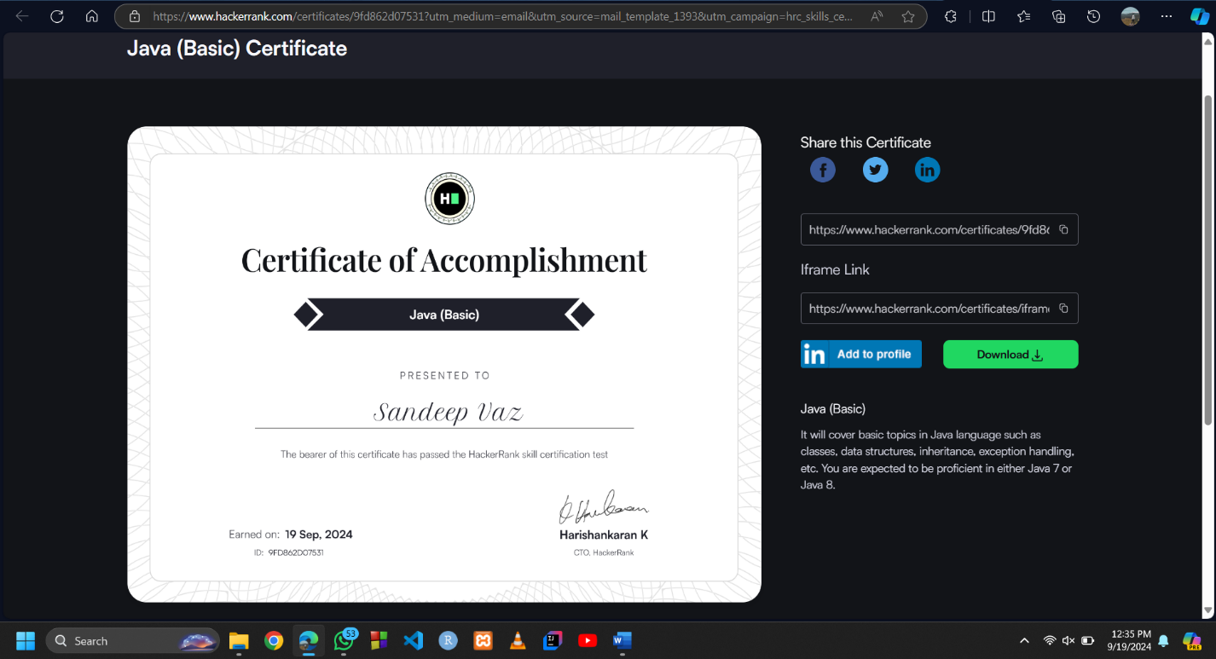**22021061 – MSN Vaz**

<https://www.hackerrank.com/certificates/9fd862d07531>